Faza II – Business Model, Entity Model i Data Layer biblioteka
Projekat: DrawSync – Real-time multiplayer drawing game
Modul: Backend (NestJS / TypeScript)
Repozitorijum: Aplikacija/backend/src/

1. Uvod

1.1 Namena dokumenta
Ovaj dokument opisuje:
- Business Model – domenski model podataka sa svim entitetima, vrednosnim objektima i poslovnim pravilima
- Entity Model – model perzistencije (baza podataka) sa tabelama, kolonama, ogranicenjima i relacijama
- Data Layer biblioteka – implementaciju funkcija za snimanje i ucitavanje business modela, uklucujuci mapiranje izmedju dva modela

1.2 Arhitekturni kontekst
Backend koristi Onion / Clean Architecture sa Ports & Adapters obrascem:
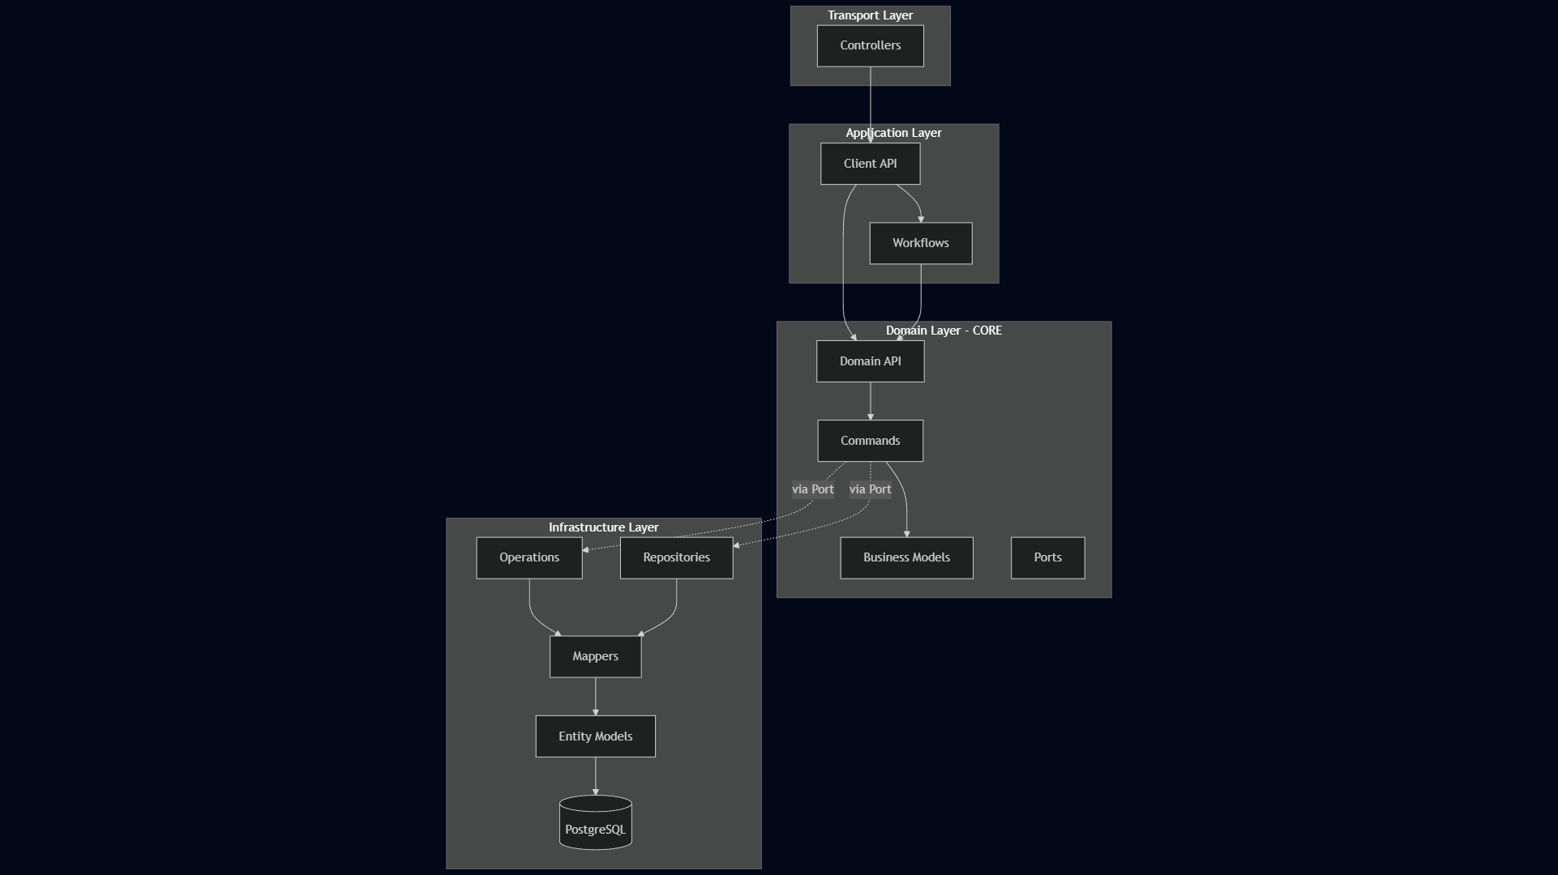

Pravilo zavisnosti: Zavisnosti uvek pokazuju ka unutra. Domenski sloj nikada ne zavisi od infrastrukture. Komunikacija sa infrastrukturom odvija se iskljucivo preko Port interfejsa koje domenski sloj definise, a infrastruktura implementira.

2. Business Model (Domain Model)
Business model se nalazi u backend/src/domain/models/ i predstavlja logicke entitete igre, nezavisne od baze podataka i infrastrukture.

2.1 Dijagram klasa

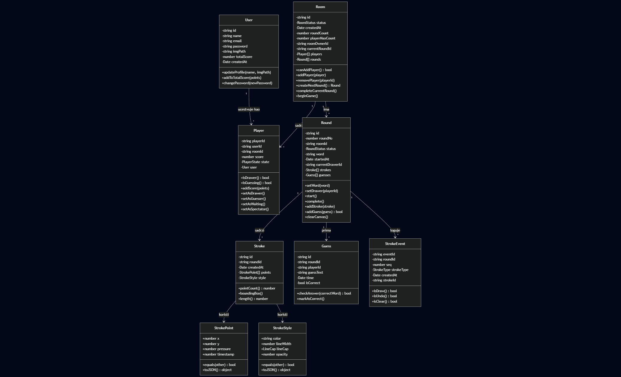

2.2 Opisi entiteta

User
Atribut | Tip | Opis
id | string (UUID) | Jedinstveni identifikator korisnika
name | string | Ime za prikaz (min 2 karaktera)
email | string | Email adresa (unique)
password | string | Hashovan password (bcrypt)
imgPath | string | null | Putanja do profilne slike
totalScore | number | Ukupan score kroz sve igre
createdAt | Date | Datum registracije
Metode: updateProfile() – azurira ime i sliku uz validaciju. addToTotalScore(points) – dodaje bodove (ne dozvoljava negativne). changePassword() – menja sifru (min 6 karaktera).
Lokacija: domain/models/user.model.ts

Player
Atribut | Tip | Opis
playerId | string (UUID) | Jedinstveni ID igraca u sobi
userId | string (UUID) | Referenca na User
roomId | string (UUID) | Referenca na Room
score | number | Bodovi u trenutnoj partiji
state | PlayerState | Trenutno stanje igraca
user | User | undefined | Opcionalni ucitani User objekat
Stanja (PlayerState enum):

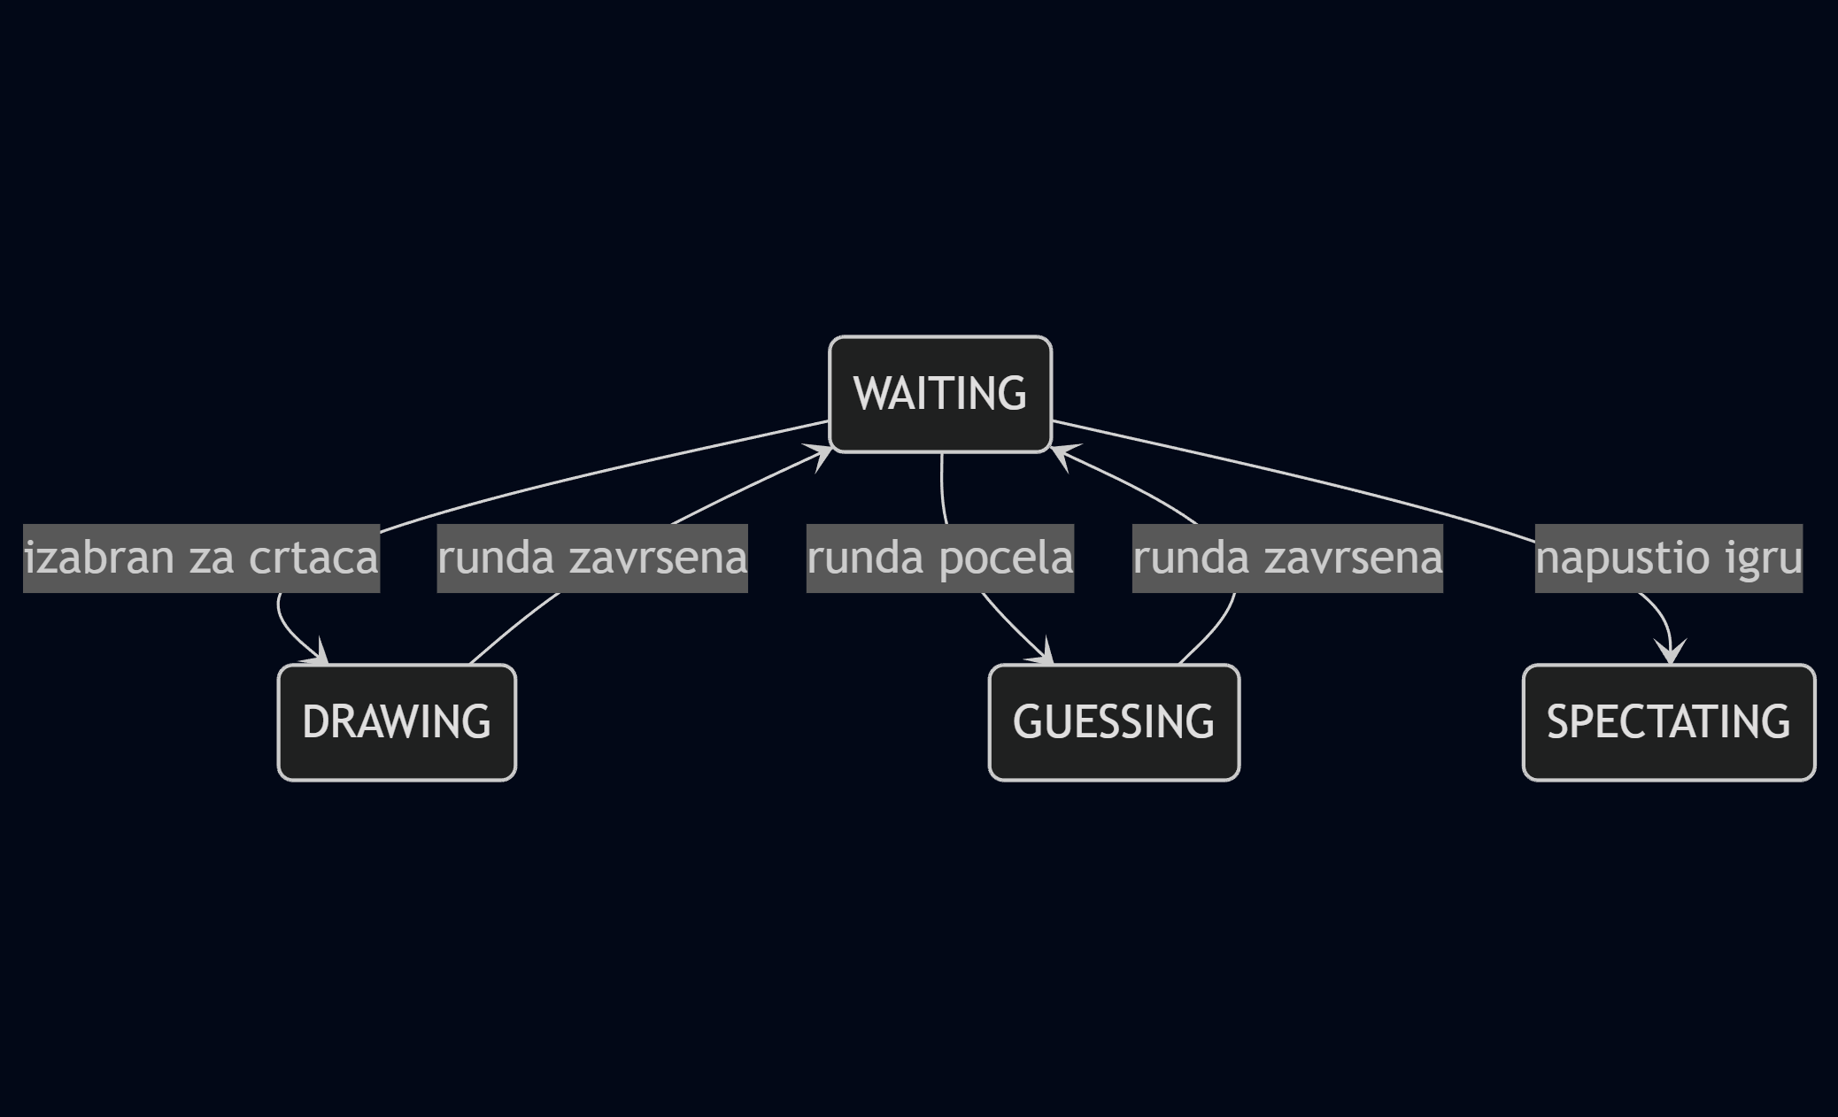

- WAITING – ceka na pocetak runde
- DRAWING – trenutno crta
- GUESSING – pogadja rec
- SPECTATING – posmatra
Lokacija: domain/models/player.model.ts

Room
Atribut | Tip | Opis
id | string (UUID) | Jedinstveni ID sobe
status | RoomStatus | Status igre
createdAt | Date | Vreme kreiranja
roundCount | number | Ukupan broj rundi (1-10)
playerMaxCount | number | Maksimalan broj igraca (2-16)
roomOwnerId | string | ID igraca koji je vlasnik sobe
currentRoundId | string | null | ID aktivne runde
players | Player[] | Lista igraca
rounds | Round[] | Lista rundi
Status (RoomStatus enum):
Poslovna pravila: - Soba je puna kada players.length >= playerMaxCount - Novi igraci mogu da se prikljuce samo u WAITING statusu - Prvi igrac automatski postaje vlasnik (roomOwnerId) - Kada vlasnik napusti sobu, vlasnistvo se prenosi na sledeceg igraca - Igra zahteva minimum 2 igraca za pocetak - Crtac se bira round-robin algoritmom ((roundNo - 1) % players.length)
Lokacija: domain/models/room.model.ts

Round
Atribut | Tip | Opis
id | string (UUID) | Jedinstveni ID runde
roundNo | number | Redni broj runde
roomId | string (UUID) | Referenca na Room
status | RoundStatus | Status runde
word | string | Tajna rec za crtanje
startedAt | Date | Vreme pocetka
currentDrawerId | string | null | ID igraca koji crta
strokes | Stroke[] | Potezi na canvasu
guesses | Guess[] | Pokusaji pogodaka
Status (RoundStatus enum):
Poslovna pravila: - Rec (word) mora biti postavljena pre pokretanja runde (min 2 karaktera) - Crtac (currentDrawerId) mora biti dodeljen pre pokretanja - Potezi (addStroke) i pogoci (addGuess) dozvoljeni samo tokom ACTIVE statusa - Crtac ne moze da pogadja svoju rec - Igrac koji je vec tacno pogodio ne moze ponovo da pogadja
Lokacija: domain/models/round.model.ts

Stroke
Atribut | Tip | Opis
id | string (UUID) | Jedinstveni ID poteza
roundId | string (UUID) | Referenca na Round
createdAt | Date | Vreme kreiranja
points | StrokePoint[] | Niz tacaka putanje (immutable)
style | StrokeStyle | Vizuelni stil poteza
Izvedeni atributi: pointCount, boundingBox, length (geometrijska duzina putanje).
Lokacija: domain/models/stroke.model.ts

Guess
Atribut | Tip | Opis
id | string (UUID) | Jedinstveni ID pogodka
roundId | string (UUID) | Referenca na Round
playerId | string (UUID) | Referenca na Player
guessText | string | Tekst pogodka (lowercase, trimmed)
time | Date | Vreme slanja
isCorrect | boolean | Da li je pogodak tacan
Metode: checkAnswer(correctWord) – poredi sa tacnom recju (case-insensitive).
Lokacija: domain/models/guess.model.ts

StrokeEvent
Atribut | Tip | Opis
eventId | string (UUID) | Jedinstveni ID eventa
roundId | string (UUID) | Referenca na Round
seq | number | Redni broj u sekvenci
strokeType | StrokeType | Tip operacije
createdAt | Date | Vreme kreiranja
strokeId | string | null | Referenca na Stroke (nullable)
StrokeType enum: DRAW, ERASE, CLEAR, UNDO
StrokeEvent je event log za event sourcing – autoritativan zapis koji omogucava replay i rekonstrukciju canvasa.
Lokacija: domain/models/stroke-event.model.ts

2.3 Vrednosni objekti (Value Objects)
Value Objects su immutable (zamrznuti sa Object.freeze) i porede se po vrednosti, ne po referenci.

StrokePoint
Atribut | Tip | Default | Opis
x | number | – | X koordinata
y | number | – | Y koordinata
pressure | number | 1 | Pritisak olovke (0-1)
timestamp | number | Date.now() | Vremenska oznaka
Podrzava equals(), toJSON() i fromJSON() za serijalizaciju.
Lokacija: domain/value-objects/stroke-point.vo.ts

StrokeStyle
Atribut | Tip | Default | Opis
color | string | – | Boja (hex ili rgb format, validiran)
lineWidth | number | – | Sirina linije (1-100, validirano)
lineCap | LineCap | 'round' | Oblik vrha (round, square, butt)
opacity | number | 1 | Providnost (0-1)
Validacija u konstruktoru: boja mora biti validan hex (#RRGGBB) ili rgb() format. Sirina mora biti izmedju 0 i 100.
Lokacija: domain/value-objects/stroke-style.vo.ts

2.4 Relacije izmedju modela
Relacija | Kardinalnost | Opis
User -> Player | 1 : N | Korisnik moze ucestvovati u vise soba istovremeno
Room -> Player | 1 : N | Soba sadrzi vise igraca
Room -> Round | 1 : N | Soba ima vise rundi
Round -> Stroke | 1 : N | Runda sadrzi vise poteza
Round -> Guess | 1 : N | Runda prima vise pogodaka
Round -> StrokeEvent | 1 : N | Runda loguje vise stroke evenata
Player -> Guess | 1 : N | Igrac moze imati vise pogodaka

3. Entity Model (Persistence Model)
Entity model se nalazi u backend/src/infrastructure/database/entities/ i predstavlja strukturu PostgreSQL baze podataka implementiranu putem TypeORM dekoratora.

3.1 ER dijagram

3.2 Opisi tabela

users
Kolona | Tip | Ogranicenja | Opis
id | UUID | PK | Primarni kljuc
name | VARCHAR(100) | NOT NULL | Ime korisnika
email | VARCHAR(255) | NOT NULL, UNIQUE | Email adresa
password | VARCHAR(255) | NOT NULL | Hashovan password
img_path | VARCHAR(500) | NULLABLE | Putanja do slike
total_score | INT | DEFAULT 0 | Ukupan score
created_at | TIMESTAMP | DEFAULT now() | Datum kreiranja
Entitet: UserEntity u database/entities/user.entity.ts

rooms
Kolona | Tip | Ogranicenja | Opis
id | UUID | PK | Primarni kljuc
status | VARCHAR(20) | DEFAULT ‘WAITING’ | Status sobe
created_at | TIMESTAMP | DEFAULT now() | Datum kreiranja
round_count | INT | DEFAULT 3 | Broj rundi
player_max_count | INT | DEFAULT 8 | Maksimum igraca
room_owner_id | UUID | FK -> players, NULLABLE | Vlasnik sobe
current_round_id | UUID | FK -> rounds, NULLABLE | Aktivna runda
Napomena: room_owner_id i current_round_id su cirkularne FK relacije – dodaju se sa ALTER TABLE nakon kreiranja zavisnih tabela.
Indeksi: IDX_rooms_status na status koloni.
Entitet: RoomEntity u database/entities/room.entity.ts

players
Kolona | Tip | Ogranicenja | Opis
player_id | UUID | PK | Primarni kljuc
user_id | UUID | FK -> users, CASCADE | Referenca na korisnika
room_id | UUID | FK -> rooms, CASCADE | Referenca na sobu
score | INT | DEFAULT 0 | Score u partiji
player_state | VARCHAR(20) | DEFAULT ‘WAITING’ | Stanje igraca
Indeksi: IDX_players_user na user_id, IDX_players_room na room_id.
Entitet: PlayerEntity u database/entities/player.entity.ts

rounds
Kolona | Tip | Ogranicenja | Opis
id | UUID | PK | Primarni kljuc
round_no | INT | NOT NULL | Redni broj runde
room_id | UUID | FK -> rooms, CASCADE | Referenca na sobu
round_status | VARCHAR(20) | DEFAULT ‘PENDING’ | Status runde
word | VARCHAR(100) | DEFAULT ’’ | Tajna rec
started_at | TIMESTAMP | NULLABLE | Vreme pocetka
current_drawer_id | UUID | FK -> players, SET NULL | Trenutni crtac
Indeksi: IDX_rounds_room na room_id.
Entitet: RoundEntity u database/entities/round.entity.ts

strokes
Kolona | Tip | Ogranicenja | Opis
id | UUID | PK | Primarni kljuc
round_id | UUID | FK -> rounds, CASCADE | Referenca na rundu
created_at | TIMESTAMP | DEFAULT now() | Vreme kreiranja
points | JSONB | NOT NULL | Niz tacaka poteza
style | JSONB | NOT NULL | Vizuelni stil poteza
JSONB format za points:
[
{"x": 100, "y": 200, "pressure": 0.5, "timestamp": 1707600000},
{"x": 120, "y": 210, "pressure": 0.7, "timestamp": 1707600016}
]
JSONB format za style:
{"color": "#FF5733", "lineWidth": 4, "lineCap": "round", "opacity": 1.0}
Indeksi: IDX_strokes_round na round_id.
Entitet: StrokeEntity u database/entities/stroke.entity.ts

stroke_events
Kolona | Tip | Ogranicenja | Opis
event_id | UUID | PK | Primarni kljuc
round_id | UUID | FK -> rounds, CASCADE | Referenca na rundu
seq | INT | NOT NULL | Redni broj u sekvenci
stroke_type | VARCHAR(20) | NOT NULL | Tip operacije
created_at | TIMESTAMP | DEFAULT now() | Vreme kreiranja
stroke_id | UUID | FK -> strokes, SET NULL, NULLABLE | Referenca na potez
Indeksi: IDX_stroke_events_round na round_id, IDX_stroke_events_seq kompozitni na (round_id, seq).
Napomena: Ova tabela je autoritativan izvor istine za replay – eventi se obradjuju sekvencijalno po seq broju.
Entitet: StrokeEventEntity u database/entities/stroke-event.entity.ts

guesses
Kolona | Tip | Ogranicenja | Opis
id | UUID | PK | Primarni kljuc
round_id | UUID | FK -> rounds, CASCADE | Referenca na rundu
player_id | UUID | FK -> players, CASCADE | Referenca na igraca
guess_text | VARCHAR(255) | NOT NULL | Tekst pogodka
time | TIMESTAMP | NOT NULL | Vreme slanja
right_guess | BOOLEAN | DEFAULT false | Da li je tacan
Indeksi: IDX_guesses_round na round_id.
Entitet: GuessEntity u database/entities/guess.entity.ts

3.3 Migracija
Inicijalna shema je definisana u migracionom fajlu database/migrations/1706900000000-InitialSchema.ts. Migracija kreira tabele odgovarajucim redosledom da bi se zadovoljile FK zavisnosti, i dodaje cirkularne FK relacije putem ALTER TABLE naredbi naknadno.

4. Mapiranje Business Modela u Entity Model
Mapiranje se vrsi putem Data Mapper klasa u backend/src/infrastructure/mappers/. Svaki mapper nasledjuje BaseMapper<DomainModel, Entity> i implementira dve metode: - toDomain(entity) – konvertuje Entity iz baze u Business Model - toEntity(domain) – konvertuje Business Model u Entity za cuvanje

4.1 Pregled mapiranja po modelu

User <-> UserEntity
Business Model (User) | Entity (UserEntity) | Napomena
id | id | Direktno
name | name | Direktno
email | email | Direktno
password | password | Direktno (hashovan)
imgPath | imgPath (kolona img_path) | snake_case u bazi
totalScore | totalScore (kolona total_score) | snake_case u bazi
createdAt | createdAt (kolona created_at) | snake_case u bazi

4.2 Sumarni pregled kljucnih razlika
Aspekt | Business Model | Entity Model
Imenovanje | camelCase (isCorrect) | snake_case u bazi (right_guess)
Enumovi | TypeScript enum (PlayerState.DRAWING) | VARCHAR string ('DRAWING')
Value Objects | Klase sa validacijom (StrokePoint) | JSONB bez validacije
Relacije | Ugnjezdeni objekti (room.players) | TypeORM relacije sa lazy loading
Identiteti | Generisani u domenu (generateUUID()) | UUID PK u bazi
Ponasanje | Metode sa biznis pravilima | Cisti podaci bez logike

5. Data Layer biblioteka

5.1 Arhitekturni obrazac
Data Layer koristi kombinaciju tri obrasca:
Obrazac | Odgovornost | Implementacija
Data Mapper | Mapiranje izmedju modela | *Mapper klase
Repository | Citanje podataka (read path) | *Repository klase
Operation | Pisanje podataka (write path) | *Operation klase

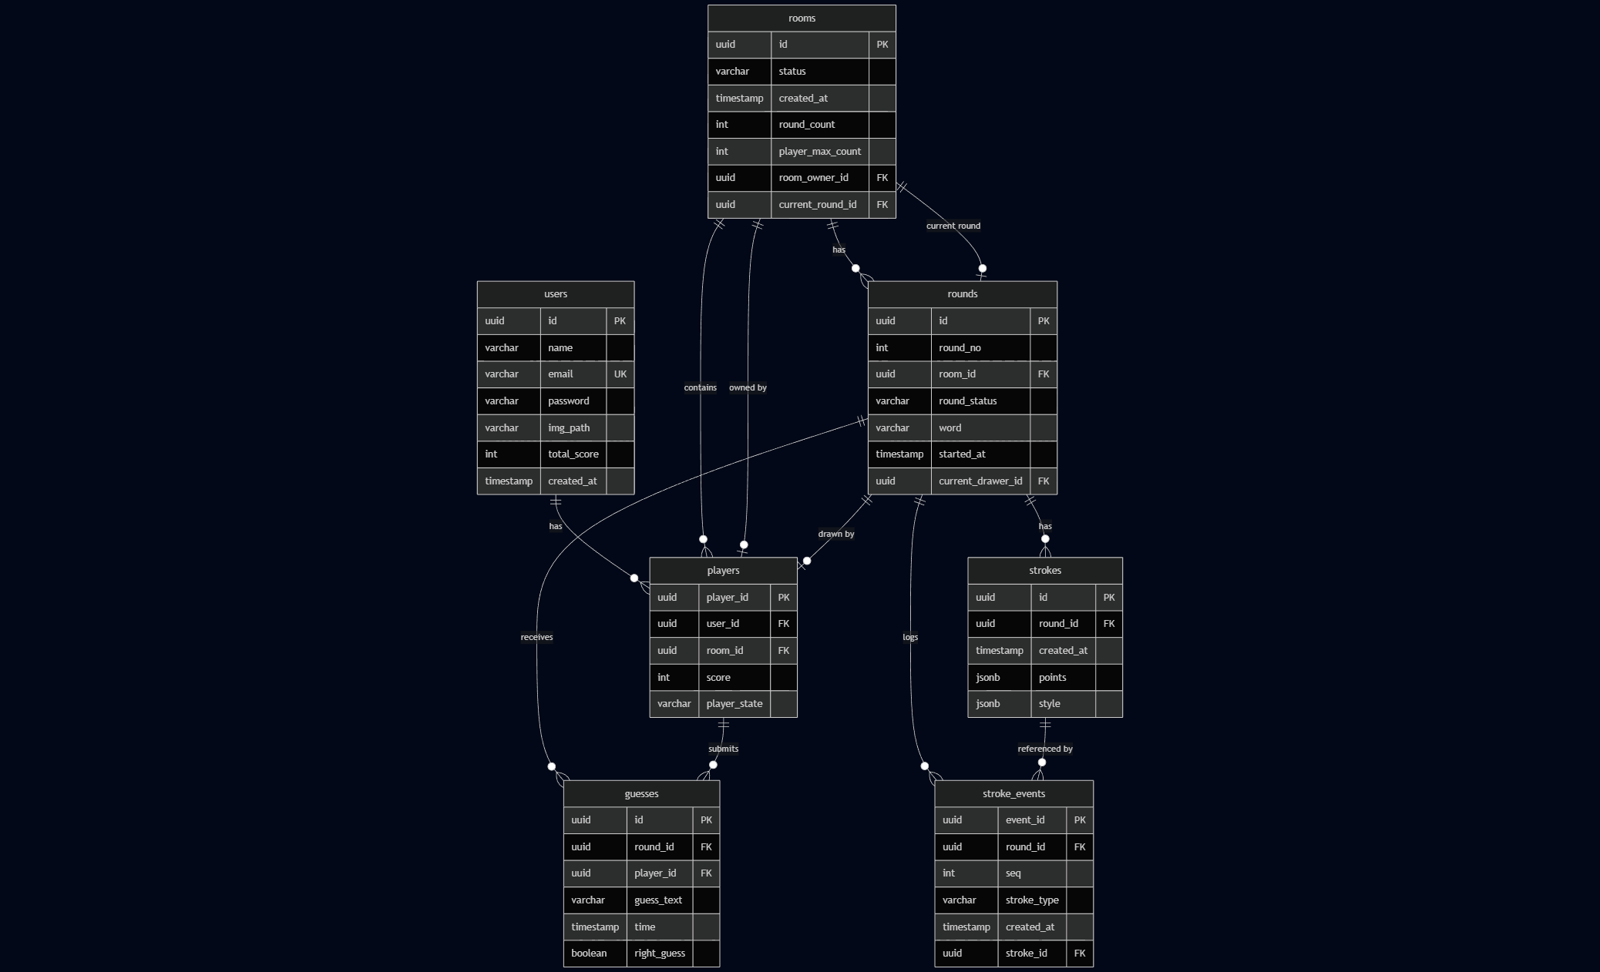

5.2 Portovi (Interfejsi)
Domenski sloj definise port interfejse koje infrastruktura implementira. Ovo osigurava da domen nikada ne zavisi od konkretne implementacije baze.

Repository portovi (citanje)
Port | Metode | Lokacija
IUserRepositoryPort | findById, findByEmail | ports/repositories/user.repository.port.ts
IRoomRepositoryPort | findById, findByIdWithPlayers, findByIdWithRounds, findByIdFull, findByStatus, findAvailableRooms, exists | ports/repositories/room.repository.port.ts
IPlayerRepositoryPort | findById, findByIdWithUser, findByRoomId, findByRoomAndUser, hasPlayerGuessedCorrectly | ports/repositories/player.repository.port.ts
IRoundRepositoryPort | findById, findByIdWithStrokes, findByIdWithGuesses, findActiveByRoomId, findByRoomId, getNextSeqForRound | ports/repositories/round.repository.port.ts
IStrokeRepositoryPort | findById, findByRoundId | ports/repositories/stroke.repository.port.ts
IStrokeEventRepositoryPort | findByRoundId | ports/repositories/stroke-event.repository.port.ts
IGuessRepositoryPort | findById, findByRoundId, findByPlayerId | ports/repositories/guess.repository.port.ts

Operation portovi (pisanje)
Port | Metoda execute(input) | Lokacija
ISaveUserOperationPort | { user: User } | ports/operations/save-user.operation.port.ts
ISaveRoomOperationPort | { room: Room } | ports/operations/save-room.operation.port.ts
ISavePlayerOperationPort | { player: Player } | ports/operations/save-player.operation.port.ts
ISaveRoundOperationPort | { round: Round } | ports/operations/save-round.operation.port.ts
ISaveStrokeOperationPort | { stroke: Stroke } | ports/operations/save-stroke.operation.port.ts
ISaveStrokeEventOperationPort | { strokeEvent: StrokeEvent } | ports/operations/save-stroke-event.operation.port.ts
ISaveGuessOperationPort | { guess: Guess } | ports/operations/save-guess.operation.port.ts
IDeleteRoomOperationPort | { roomId: string } | ports/operations/delete-room.operation.port.ts
IRemovePlayerOperationPort | { playerId: string } | ports/operations/remove-player.operation.port.ts
IUpdateRoundStatusOperationPort | { roundId, status } | ports/operations/update-round-status.operation.port.ts
IUpdatePlayerScoreOperationPort | { playerId, points } | ports/operations/update-player-score.operation.port.ts
IUpdateUserScoreOperationPort | { userId, points } | ports/operations/update-user-score.operation.port.ts

5.3 Implementacija Repository-ja (Read Path)
Svaki repository: 1. Prima TypeORM Repository<Entity> putem @InjectRepository 2. Izvrsava upit koristeci TypeORM Query API 3. Konvertuje rezultat iz Entity u Business Model putem odgovarajuceg Mappera 4. Vraca Business Model pozivaocu
Primer – RoomRepository:
// infrastructure/repositories/room.repository.ts
@Injectable()
export class RoomRepository implements IRoomRepositoryPort {
constructor(
@InjectRepository(RoomEntity)
private readonly roomRepo: Repository<RoomEntity>,
private readonly mapper: RoomMapper
) {}
async findByIdWithPlayers(id: string): Promise<Room | null> {
const entity = await this.roomRepo.findOne({
where: { id },
relations: { players: true } // eager load players
});
return entity ? this.mapper.toDomain(entity) : null;
// ^^^^^^^^^^^^^^^^^^^^^^^^
// Entity -> Business Model konverzija
}
}

5.4 Implementacija Operation-a (Write Path)
Svaka operacija: 1. Prima Business Model kao ulaz 2. Konvertuje ga u Entity putem Mappera 3. Cuva Entity u bazu putem TypeORM 4. Ne sadrzi nikakvu biznis logiku
Primer – SaveGuessOperation:
// infrastructure/operations/guess/save-guess.operation.ts
@Injectable()
export class SaveGuessOperation implements ISaveGuessOperationPort {
constructor(
@InjectRepository(GuessEntity)
private readonly guessRepo: Repository<GuessEntity>,
private readonly mapper: GuessMapper
) {}
async execute(input: { guess: Guess }): Promise<void> {
const entity = this.mapper.toEntity(input.guess);
// ^^^^^^^^^^^^^^^^^^^^^^^^^^^^^^^^^
// Business Model -> Entity konverzija
await this.guessRepo.save(entity);
}
}
Primer – UpdatePlayerScoreOperation (atomski update):
// infrastructure/operations/score/update-player-score.operation.ts
async execute(input: { playerId: string; points: number }): Promise<void> {
await this.playerRepo.increment(
{ playerId: input.playerId },
'score',
input.points
);
// Atomski increment -- ne zahteva prethodno ucitavanje
}

5.5 BusinessModelPersistence – Fasadna biblioteka
BusinessModelPersistence je fasadna klasa koja objedinjuje sve Repository i Operation pozive u jedinstven API za snimanje i ucitavanje Business Modela.
Lokacija: infrastructure/data-layer/business-model.persistence.ts

API za ucitavanje (Load)
Metoda | Parametri | Vraca | Opis
loadRoom(roomId, options) | roomId: string, options: { withPlayers?, withRounds?, full? } | Room | null | Ucitava sobu sa opcionalnim relacijama
loadRound(roundId, options) | roundId: string, options: { withStrokes?, withGuesses? } | Round | null | Ucitava rundu sa opcionalnim relacijama
loadRoundEventLog(roundId) | roundId: string | StrokeEvent[] | Ucitava event log za replay

API za snimanje (Save)
Metoda | Parametar | Opis
saveRoom(room) | Room | Snima/azurira sobu
savePlayer(player) | Player | Snima/azurira igraca
saveRound(round) | Round | Snima/azurira rundu
saveStroke(stroke) | Stroke | Snima potez
saveStrokeEvent(event) | StrokeEvent | Snima stroke event
saveGuess(guess) | Guess | Snima pogodak
removePlayer(playerId) | string | Brise igraca iz sobe
deleteRoom(roomId) | string | Brise celu sobu (CASCADE)

6. End-to-End Flow primeri

6.1 Primer 1: Registracija korisnika (POST /api/auth/register)
Ovaj primer pokazuje kompletan tok od HTTP zahteva do upisa u bazu.

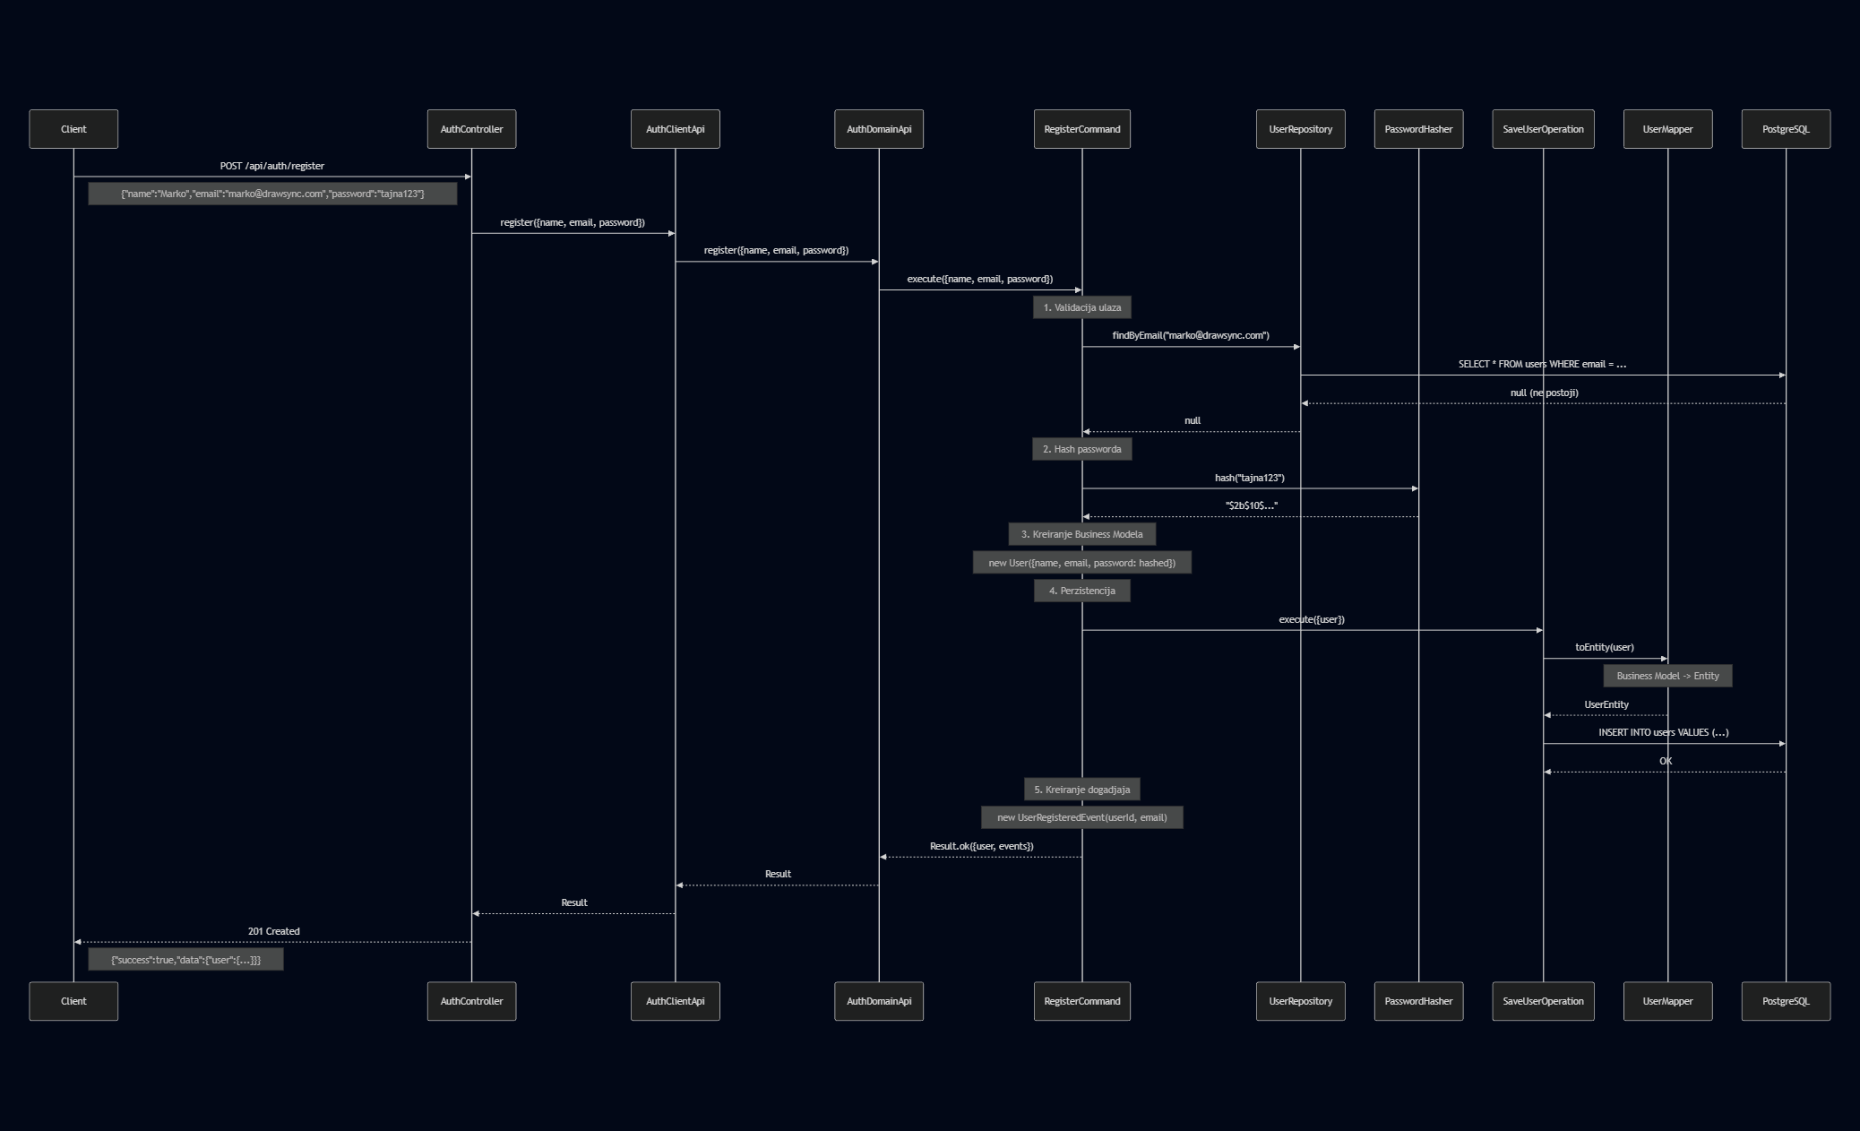

Tok podataka kroz slojeve
Korak 1 – HTTP zahtev (Transport Layer)
POST /api/auth/register
Content-Type: application/json
{
"name": "Marko Petrovic",
"email": "marko@drawsync.com",
"password": "tajna123"
}
Controller mapira DTO u poziv Client API-ja:
// auth.controller.ts
const result = await this.authClientApi.register({
name: dto.name, // "Marko Petrovic"
email: dto.email, // "marko@drawsync.com"
password: dto.password // "tajna123"
});
Korak 2 – Delegacija (Application Layer)
Client API prosledjuje poziv Domain API-ju bez ikakve logike:
// auth.client-api.ts
const result = await this.authDomainApi.register({
name: request.name, email: request.email, password: request.password
});
Korak 3 – Biznis logika (Domain Layer – RegisterCommand)
// register.command.ts
// a) Validacija
if (!input.name || input.name.trim().length < 2) return Result.fail(...);
if (!input.email || !input.email.includes('@')) return Result.fail(...);
if (!input.password || input.password.length < 6) return Result.fail(...);
// b) Provera jedinstvenosti emaila (read path)
const existingUser = await this.userRepo.findByEmail(input.email);
if (existingUser) return Result.fail('Email is already registered', 'EMAIL_TAKEN');
// c) Hashovanje passworda
const hashedPassword = await this.passwordHasher.hash(input.password);
// d) Kreiranje Business Modela
const user = new User({
name: 'Marko Petrovic',
email: 'marko@drawsync.com',
password: '$2b$10$...' // hashovan
});
// user.id = generisan UUID, npr. "9f8e7d6c-5b4a-3210-fedc-ba9876543210"
Korak 4 – Perzistencija (Infrastructure Layer)
// register.command.ts -> poziva Operation port
await this.saveUserOp.execute({ user });
SaveUserOperation konvertuje Business Model u Entity:
// save-user.operation.ts
const entity = this.mapper.toEntity(input.user);
// entity = UserEntity {
// id: "9f8e7d6c-5b4a-3210-fedc-ba9876543210",
// name: "Marko Petrovic",
// email: "marko@drawsync.com",
// password: "$2b$10$...",
// imgPath: null,
// totalScore: 0,
// createdAt: 2026-02-11T...
// }
await this.userRepo.save(entity);
Korak 5 – Rezultat u bazi
drawsync=# SELECT * FROM users WHERE email = 'marko@drawsync.com';
id | name | email | password | img_path | total_score | created_at
---------------------+----------------+----------------------+--------------+----------+-------------+--------------------
9f8e7d6c-5b4a-... | Marko Petrovic | marko@drawsync.com | $2b$10$... | NULL | 0 | 2026-02-11 18:40:31

6.2 Primer 2: Slanje pogodka (POST /api/rooms/{roomId}/guesses)
Ovaj primer pokazuje slozeniji tok koji ukljucuje i citanje i pisanje, validaciju poslovnih pravila, i azuriranje vise tabela.

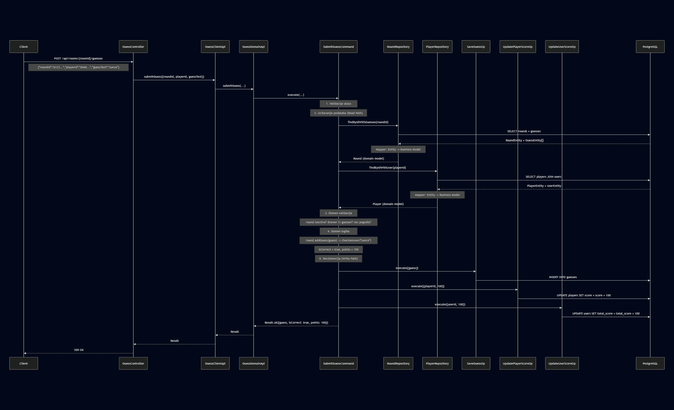

Detalji poslovne logike u SubmitGuessCommand
Validacija poslovnih pravila:
// submit-guess.command.ts
// Round mora biti aktivan
if (!round.isActive)
return Result.fail('Round is not active', 'INVALID_STATE');
// Crtac ne moze da pogadja
if (round.currentDrawerId === input.playerId)
return Result.fail('Drawer cannot guess', 'NOT_AUTHORIZED');
// Igrac koji je vec pogodio ne moze ponovo
const alreadyGuessed = await this.playerRepo
.hasPlayerGuessedCorrectly(input.roundId, input.playerId);
if (alreadyGuessed)
return Result.fail('Player has already guessed correctly', 'ALREADY_GUESSED');
Sistem bodovanja:
// Bodovi se smanjuju sa svakim narednim tacnim pogodkom
private calculatePoints(previousCorrectGuesses: number): number {
const basePoints = 100; // prvi tacan pogodak
const decrement = 20; // smanjenje po sledecim
const minPoints = 20; // minimum bodova
return Math.max(basePoints - (previousCorrectGuesses * decrement), minPoints);
}
// 1. tacan pogodak: 100 bodova
// 2. tacan pogodak: 80 bodova
// 3. tacan pogodak: 60 bodova
// ...
// 5+ tacan pogodak: 20 bodova (minimum)
Upis u vise tabela:
Uspesno pogadjanje azurira tri tabele:
Tabela | Operacija | SQL
guesses | INSERT | Nova stavka sa right_guess = true
players | UPDATE | score = score + 100 (atomski increment)
users | UPDATE | total_score = total_score + 100 (atomski increment)

7. Dependency Injection i Module Wiring

7.1 Vezivanje portova za implementacije
PersistenceModule (infrastructure/persistence.module.ts) je centralno mesto gde se Port interfejsi vezuju za konkretne implementacije putem NestJS dependency injection sistema.
Portovi se registruju koristeci string token obrazac:
// infrastructure/persistence.module.ts
@Module({
providers: [
// Maperi
UserMapper, PlayerMapper, RoomMapper, RoundMapper,
StrokeMapper, StrokeEventMapper, GuessMapper,
// Konkretne implementacije
RoomRepository, UserRepository, PlayerRepository, ...
SaveRoomOperation, SaveUserOperation, SaveGuessOperation, ...
// Vezivanje porta za implementaciju
{ provide: 'IRoomRepositoryPort', useClass: RoomRepository },
{ provide: 'IUserRepositoryPort', useClass: UserRepository },
{ provide: 'ISaveUserOperationPort', useClass: SaveUserOperation },
{ provide: 'ISaveGuessOperationPort', useClass: SaveGuessOperation },
{ provide: 'IPasswordHasherPort', useClass: PasswordHasherAdapter },
{ provide: 'ITokenProviderPort', useClass: TokenProviderAdapter },
// ... ostali portovi
],
exports: [
'IRoomRepositoryPort', 'IUserRepositoryPort',
'ISaveUserOperationPort', 'ISaveGuessOperationPort',
// ... svi portovi se exportuju za koriscenje u drugim modulima
]
})
export class PersistenceModule {}

7.2 Kako Command prima zavisnosti
Domain Command-e primaju Repository i Operation implementacije putem @Inject dekoratora sa string tokenom – nikada ne importuju konkretnu klasu iz infrastrukture:
// domain/commands/auth/register.command.ts
@Injectable()
export class RegisterCommand {
constructor(
@Inject('IUserRepositoryPort') // Port interfejs
private readonly userRepo: IUserRepositoryPort,
@Inject('IPasswordHasherPort') // Port interfejs
private readonly passwordHasher: IPasswordHasherPort,
@Inject('ISaveUserOperationPort') // Port interfejs
private readonly saveUserOp: ISaveUserOperationPort
) {}
// Command koristi SAMO interfejse -- ne zna za TypeORM, PostgreSQL, bcrypt...
}
Ovo osigurava da domenski sloj ostaje potpuno nezavisan od infrastrukture – moze se testirati sa mock implementacijama portova bez ikakve baze podataka.

